Postal Life Insurance

Department of Post

Software Requirements Specification (SRS)/ Functional Requirements Specification (FRS)
Agent Change

INTERNAL APPROVAL FORM

Project Name: Agent Change
Version: 1.0
Submitted on:
 | Name | Date
Approved By:
Reviewed By:
Prepared By:

VERSION CONTROL LOG
Version | Date | Prepared By | Remarks
1

Table of Contents

1. Executive Summary 4
2. Project Scope 4
3. Business Requirements 4
4. Functional Requirements Specification 4
4.1 Non-Financial Service Request Indexing page 4
4.2 Agent Change Page 5
5. Attachments 5

1. Executive Summary
The Agent Change module enables policyholders to request a change in their assigned agent for servicing their Postal Life Insurance (PLI) policy. This may be required due to suspension on group of fraud, removal and resignation of the agent, or other valid reasons. The system must ensure proper validation, approval workflow, and audit tracking for such changes.

2. Project Scope
This scope will include the following modules:
- Agent Change Process
- Automatically update commission mapping and policy.
- Provide real-time notifications and centralized audit logs.

3. Business Requirements

ID | Requirements
FS_AC_001 | Allow digital initiation of agent change request from IT 2.0 System, mobile app and customer portal
FS_AC_002 | Validate new agent’s eligibility and jurisdiction using Agent Master.
FS_AC_003 | Automatically recalculate commission mapping and update policy.
FS_AC_004 | Notify stakeholders (customer, old agent, new agent, admin) via SMS/Email.
FS_AC_005 | Maintain centralized audit trail for all agent change actions.
FS_AC_006 | Restrict agent selection to eligible agents within customer’s jurisdiction.
FS_AC_007 | Allow uploading of supporting documents (if required).
FS_AC_008 | Provide acknowledgment receipt to customer upon request submission.

4. Functional Requirements Specification
Flow Diagram for Agent Change Process: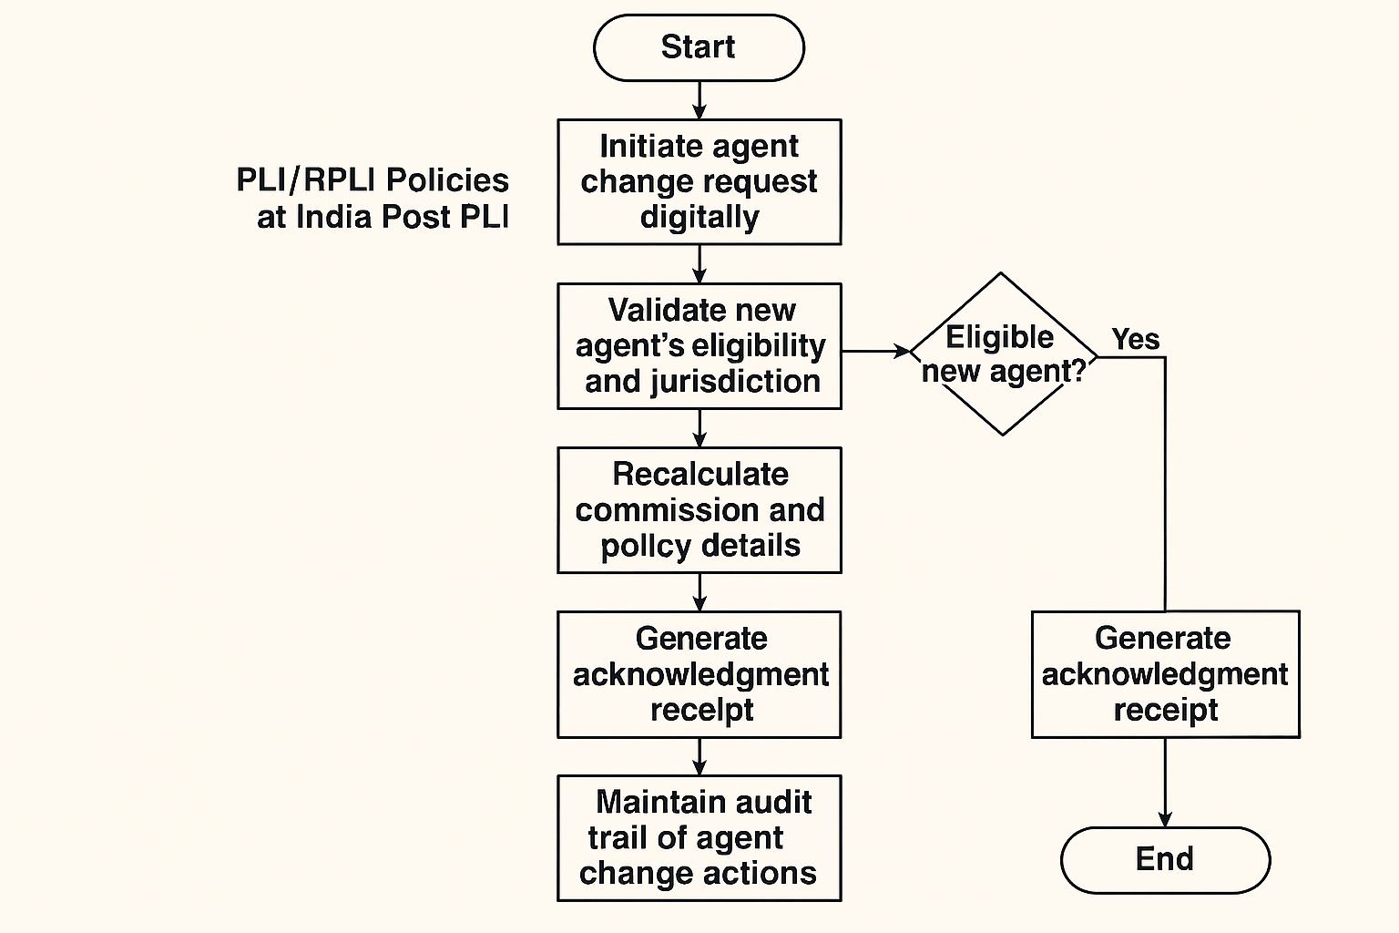

4.1 Non-Financial Service Request Indexing page
- Purpose: To create Non-Financial Service Request for Agent Change.
- Fields:
  - Request Type: Option should include service request type like Agent Change, etc.
  - Service Request Date: Calendar: Date on which service request is indexed.
  - Policy Number: Text
  - Current Agent ID: Option to search and Select the Agent should be present.
  - New Agent ID: Option to search and Select the Agent should be present.
  - Office Code: Text: Facility ID of the office where request is getting indexed
  - Service Request Channel: Text: Channel for the service request like RICT, CP etc.
  - Username: Text: Emp ID of the user indexing the request
- Rules:
  - Request should get created and CPC User should be able to open the details.

4.2 Agent Change Page
- Purpose: To perform the Agent Change for the Policy.
- Field:
  - Request Type: Auto-Populated
  - Ticket No.: Auto-Populated
  - Policy Number (auto-validated)
  - Customer Name (auto-filled)
  - Current Agent Code & Name (auto-filled)
  - Reason for Agent Change (dropdown + remarks)
  - Select New Agent (dropdown filtered by jurisdiction & eligibility)
  - Upload Supporting Document (optional)
  - Submit: Button
- Rules:
  - Clicking on Submit button should update the Agent details of the Policy.
  - It should Automatically recalculate commission mapping and all future commission should go to new agent.
  - Upon Successful completion of Agent Change process, notification should be sent to Mobile/Email/Whatsapp of both previous and new agent along with the policy owner.

5. Attachments
The following documents can be referred.

